Michael MacKay

COMP 2681

June 17, 2019

**Description of Business**

Prairie Land Battlebots is a local robot fighting league run out of J.C. Charyk Hanna School. It started as a project-based learning project in the 2018 – 2019 school year for Jr. High students. Students handle most aspects of the league, whether it be designing and building robots or creating the rulebook. The 2019 – 2020 school year will bring Prairie Land Battlebots into its second year with new students and teams.

**Project Description**

The Prairie Land Battlebots website is designed around being a small, aesthetically pleasing website that gives users access to upcoming events, team information and contact information.

**Project Objectives**

* Create awareness in the community and other school divisions for the purpose of:
  + Interesting more possible teams to join the program
  + Promote the program, the school and the division.
* Create an online presence to allow others to:
  + View news, teams, and upcoming events.
  + Hold information about join (once it is completed)
  + Contact the organization
* Ensure Credibility in the Program

**Site Map**

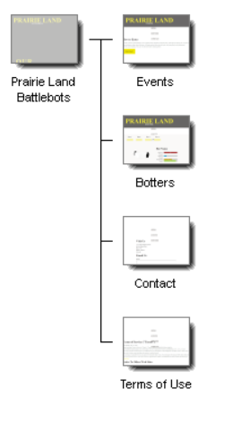

**Benefits**

* Establish and maintain credibility as Robot Fighting League
  + Having a website increase the credibility of an organization as it has a global “meeting” spot that gives Prairie Land Battles an online identity.
* Increased Awareness of the program
  + The website allows other people, teams and school divisions to inquiry into the program. Also, using SOE (search engine optimization), the website can reach other clients around the world.
* Promotion
  + Along with an increased online presence, the website will promote the Prairie Land Battlebots brand, along with the school and school division as an innovated place of learning.
* Celebration and Showcase of Achievements
  + Students can use the website to showcase their achievements. For example, the construction of their bot can be displayed on the “Botters” page and tournament champions can be announced on the landing page.
* Availability/Convenience
  + The website gives potential customs 24-7 accessibility to information about5 the program.